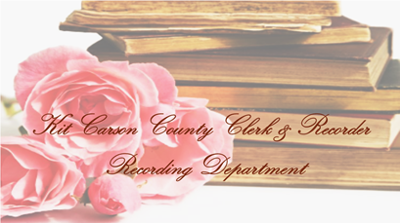
KIT CARSON COUNTY

CLERK AND RECORDER

Susan Corliss, County Clerk

251 16th St. P.O. Box 249
Burlington, CO 80807-0249
Phone 719-346-8638

REQUEST FOR COPY OF MARRIAGE LICENSE APPLICATION

Generally, the Colorado Open Records Act permits access to a variety of information. However, such access is denied when it would be contrary to any State or Federal statute or regulation. (CRS 24-72-204)

In 2006, Colorado enacted legislation restricting access to Applications for a Marriage License to a person of interest. (CRS 24-82-204) a “Person of Interest” includes an immediate family member of either party to the marriage application. An “Immediate Family Member” means a person who is related by blood, marriage, or adoption. The other exception to the law is release upon a Court Order or if the marriage application record is at least 50 years old. This for is NOT required if a Court Order is present to us. This office will enforce those requirements.

For a copy of the Marriage License Application please complete the following authorization.
PHOTO IDENTIFICATION IS REQUIRED IN ORDER TO PROCESS A REQUEST

“I authorize or request the Kit Carson County Clerk and Recorder to release a copy of the Application for Marriage that was issued to:

________________________________ And _________________________________
Groom Bride

Date of Marriage: _______________________________________________________

I do certify that I am a party to the marriage or related to one of the parties to the marriage by Blood, marriage, or adoption or that the marriage application is at least 50 years old. (Circle One).

Signature of Requestor: __________________________________________________

Party Related to: ________________________________________________________

By: _________________________________________Date: ________________

ID NO. ______________________________________ID Type: ______________

